NAME : SHYAM SUNDAR K
REG NO : 241801268
EXP NO : 6

1. SELECT SYSDATE AS "Date" FROM dual;
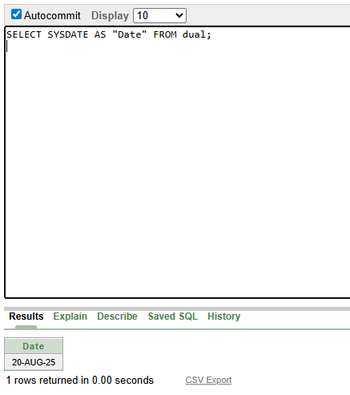

2. SELECT employee_id,
last_name,
salary,
ROUND(salary * 1.155) AS "New Salary"
FROM employees;
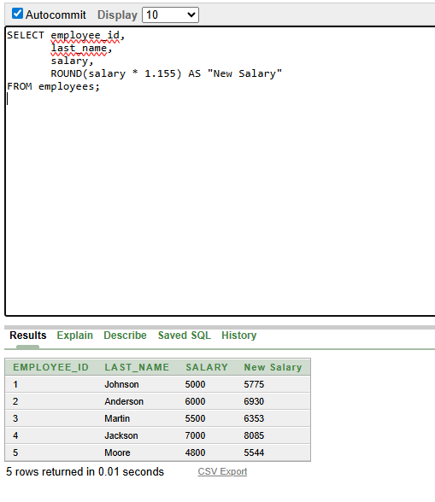

3. SELECT employee_id,
last_name,
salary,
ROUND(salary * 1.155) AS "New Salary",
ROUND(salary * 1.155) - salary AS "Increase"
FROM employees;
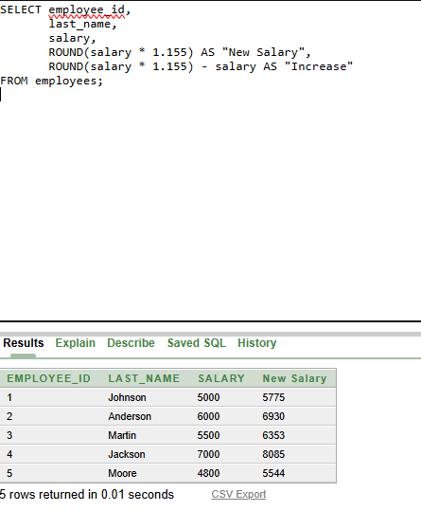

4. SELECT INITCAP(last_name) AS "Last Name", LENGTH(last_name) AS "Name Length" FROM employees WHERE UPPER(SUBSTR(last_name, 1, 1)) IN ('J', 'A', 'M') ORDER BY last_name;
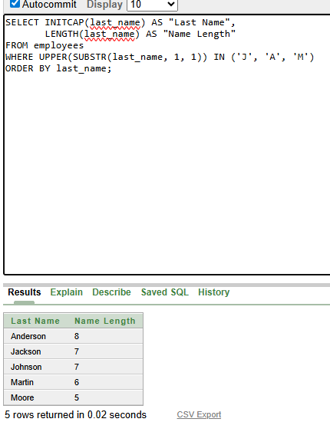

5. SELECT last_name, salary FROM employees WHERE UPPER(SUBSTR(last_name, 1, 1)) = :letter;
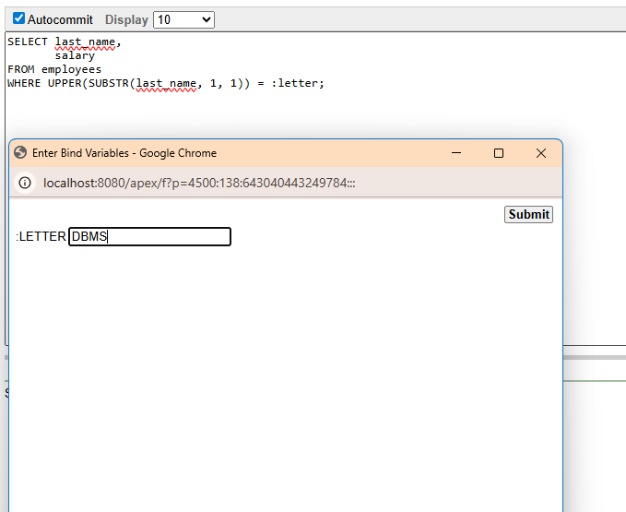

6. SELECT last_name, CEIL(MONTHS_BETWEEN(SYSDATE, hire_date)) AS "MONTHS_WORKED" FROM employees ORDER BY CEIL(MONTHS_BETWEEN(SYSDATE, hire_date));
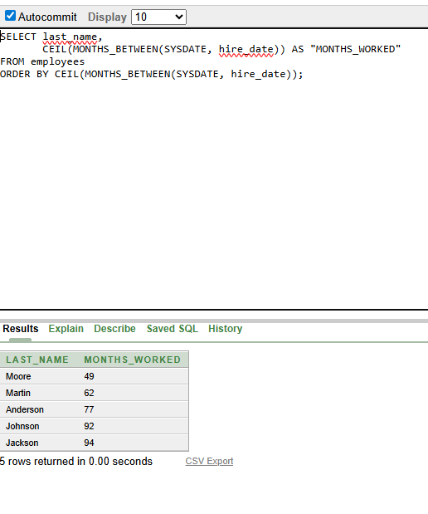

7. SELECT last_name || ' earns ' || TO_CHAR(salary) || ' monthly but wants ' || TO_CHAR(salary * 3) AS "Dream Salaries"
FROM employees;

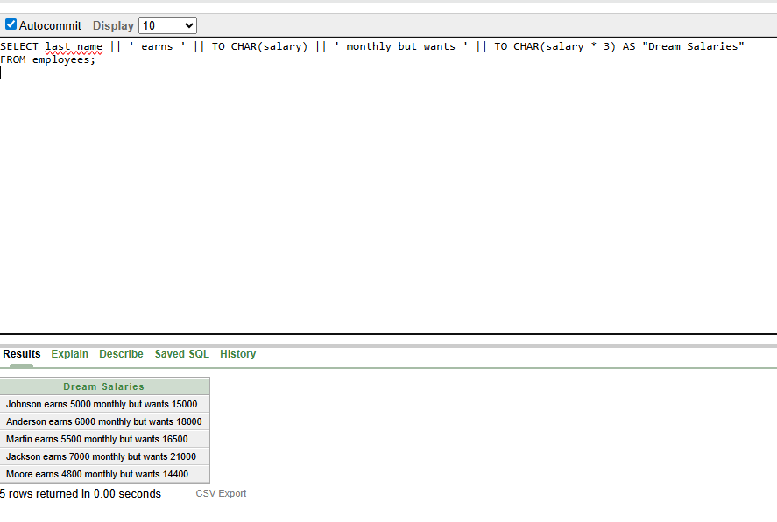

8. SELECT last_name, LPAD(TO_CHAR(salary), 15, '$') AS SALARY FROM employees;
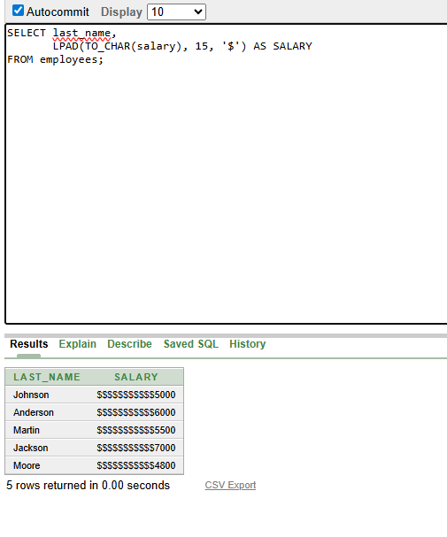

9. SELECT last_name, TO_CHAR(hire_date, 'Day, "the" FMDDTH "of" Month, YYYY') AS hire_date, TO_CHAR( NEXT_DAY(ADD_MONTHS(hire_date, 6) - 1, 'MONDAY'), 'Day, "the" FMDDTH "of" Month, YYYY' ) AS REVIEW FROM employees;
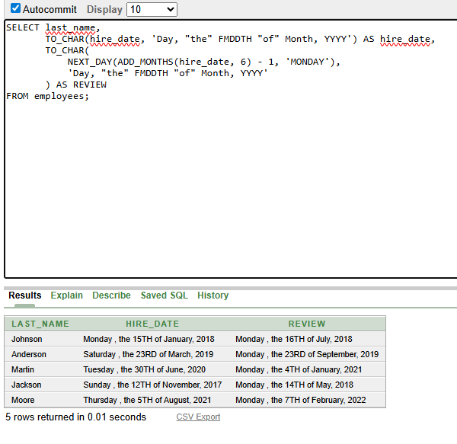

10. SELECT last_name, hire_date, TO_CHAR(hire_date, 'Day') AS DAY FROM employees ORDER BY CASE TO_CHAR(hire_date, 'DY', 'NLS_DATE_LANGUAGE=ENGLISH') WHEN 'MON' THEN 1 WHEN 'TUE' THEN 2 WHEN 'WED' THEN 3 WHEN 'THU' THEN 4 WHEN 'FRI' THEN 5 WHEN 'SAT' THEN 6 WHEN 'SUN' THEN 7 END;

